kNOwVAWdata

Reflection Journal
Subject 2, Tutorial 1: Measuring Violence against Women
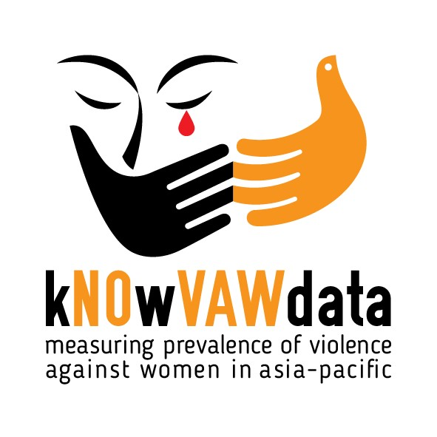

Participant name _________________________________________________________

Purpose of this Reflection Journal

The aim of the Reflection Journal is to apply course content to the specific cultural and country context where you’ll be working. The idea of this journal is that it provides you an opportunity to reflect more deeply on the content, therefore we expect each response to be approximately half to one page in length.

Throughout each subject you will be directed to your Reflection Journal to complete activities. Each subject you undertake will have its own Reflection Journal.

You may also like to share your responses on the Discussion Board. However, this is not mandatory.

Assessment

This reflection journal will be assessed using the following rubric. Students will be assigned an overall assessment of highly proficient, competent or not yet competent.

 | Highly proficient | Competent | Not yet competent
Understanding of concepts related to gender awareness | Knowledge of key theoretical concepts is very effectively demonstrated. | Knowledge of key concepts is reasonably demonstrated. | Knowledge about key theoretical concepts is not adequately demonstrated.
Reflective and critical skills | Sophisticated and thoughtful observations with a high level of insight and analysis, as reflected in journal responses. | Adequate degree of observation with some insight and analysis. Thoughtful reflection journal responses but lacking depth. | Simplistic observation. Provides little or no insight, comment or analysis. More descriptive than reflective.

Submission details

Please save this document as: ‘[Participant Name]_Subject 2 Reflection Journal’ and email to tl-knowvaw@unimelb.edu.au by 11.59pm 15th March, 2021.

Contact us

If you have any questions, please contact us at:
tl-knowvaw@unimelb.edu.au

Activity 1
Thinking about the international mandates explored above, review the interactive map developed by the UN with information for each country, as well as the UN overview of Member States' commitments to the SDGs.
Has the country you’re working in ratified CEDAW? Are they a signatory?
- Is your country a Member State of the United Nations?
- Briefly summarise the key commitments your country has made to working towards accomplishing the SDGs.

Activity 2

There are separate indicators on partner and non‐partner violence (indicators 5.2.1 and 5.2.2), and both cover sexual violence.

- What are some of the possible reasons for separating these indicators?
- How might the separation of these indicators be helpful for measuring VAW in your country context?

Activity 3
Thinking about what you’ve learned so far about the indicators used to measure violence against women, answer the following question:
- Which of these indicators do you think are the most difficult to measure? Explain your opinion, using examples from your own experience and context

Activity 4

In your country, identify and locate any prevalence surveys that have been conducted. Briefly report on:
- The ways in which violence has been defined.
- How the study population has been defined, including cut-off ages and marital/relationship experience.

